.

Why should I take AP Human Geography

Over the years at Union Grove High School, you might take many AP classes.

But, this is the only AP course offered to up-coming freshmen.

This will prepare you for other AP and Honors classes you might take in the future.

If you plan on going to college, the AP program will help you earn college credit. You will have the option of taking the AP College Board exam in May that can earn you college course credit!

AP® courses are commonly the most difficult classes offered at most high schools. Colleges want to see that students have taken the most challenging courses.

This is an elective course but does help meet the rigor requirements for the HOPE scholarship and Zell Miller.

Topics of study include: Population, Migration, Economic Development, Urban planning, Environment, Industrialization, Culture, Religion, Language, Politics, Race, Gender, and Agriculture.

AP Human Geography will help you become a more aware global citizen! You will find out EVERYTHING can be related to AP Human Geography.

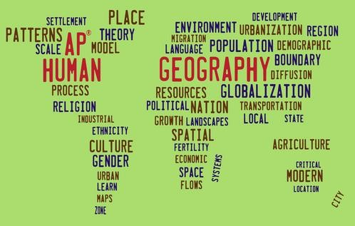You will develop skills and learn vocabulary that will help you in your other courses throughout high school and college.

Who should take the course?

* Desire to attend college and take additional AP classes
* Willingness to personally invest effort throughout the academic year
* Desire to Grow as Scholars through Research, Critical Reading, and Creative Thinking
* You should be someone who turns in work and on time.
* Someone interested in understanding the Global issues and how

they connect and relate to you! AP HUG will discuss the following:

* + Migration (why and how people, ideas, goods/services and diseases diffuse/move around the world
  + Population concerns (will we have enough resources?)
  + Culture (ethnicity, religion, pop versus tradition cultures, languages,)
  + Political Geography
  + Economics (agriculture, industry, international trade)
  + Urbanization / living patterns and choices human’s make
* If you have any questions please feel free to email me anytime at [aokrutny@henry.k12.ga.us](mailto:aokrutny@henry.k12.ga.us)